Ryan Young   
CSE 2300w

Section 03

Haitham

**Three Out of Four**

**Objectives:**

The objective of this lab was to work with and get better using the hardware version of D flipflops. Since we need to use flipflops we also will gain practice using truth tables, Karnaugh Maps, and state diagrams.

**Background:**

The theory for this lab is based off communication systems that use start and stop codes to delineate the data. This bit counting relies on storing a state in a series of flipflops which tell the system where you are in the processing of the data. -KB Pdf file

**Procedure:**

1. Determine how many states are required, define them and determine what they mean.
2. Draw a state diagram and indicate the input and output at each transition.
3. Create a transition table and use the D flipflops for the implementation.
4. Draw your Karnaugh Maps and create the minimized functions.
5. Build the circuit in logicworks and ensure that it works properly.
6. Build and test your hardware circuit on your proto board.

**Results:**

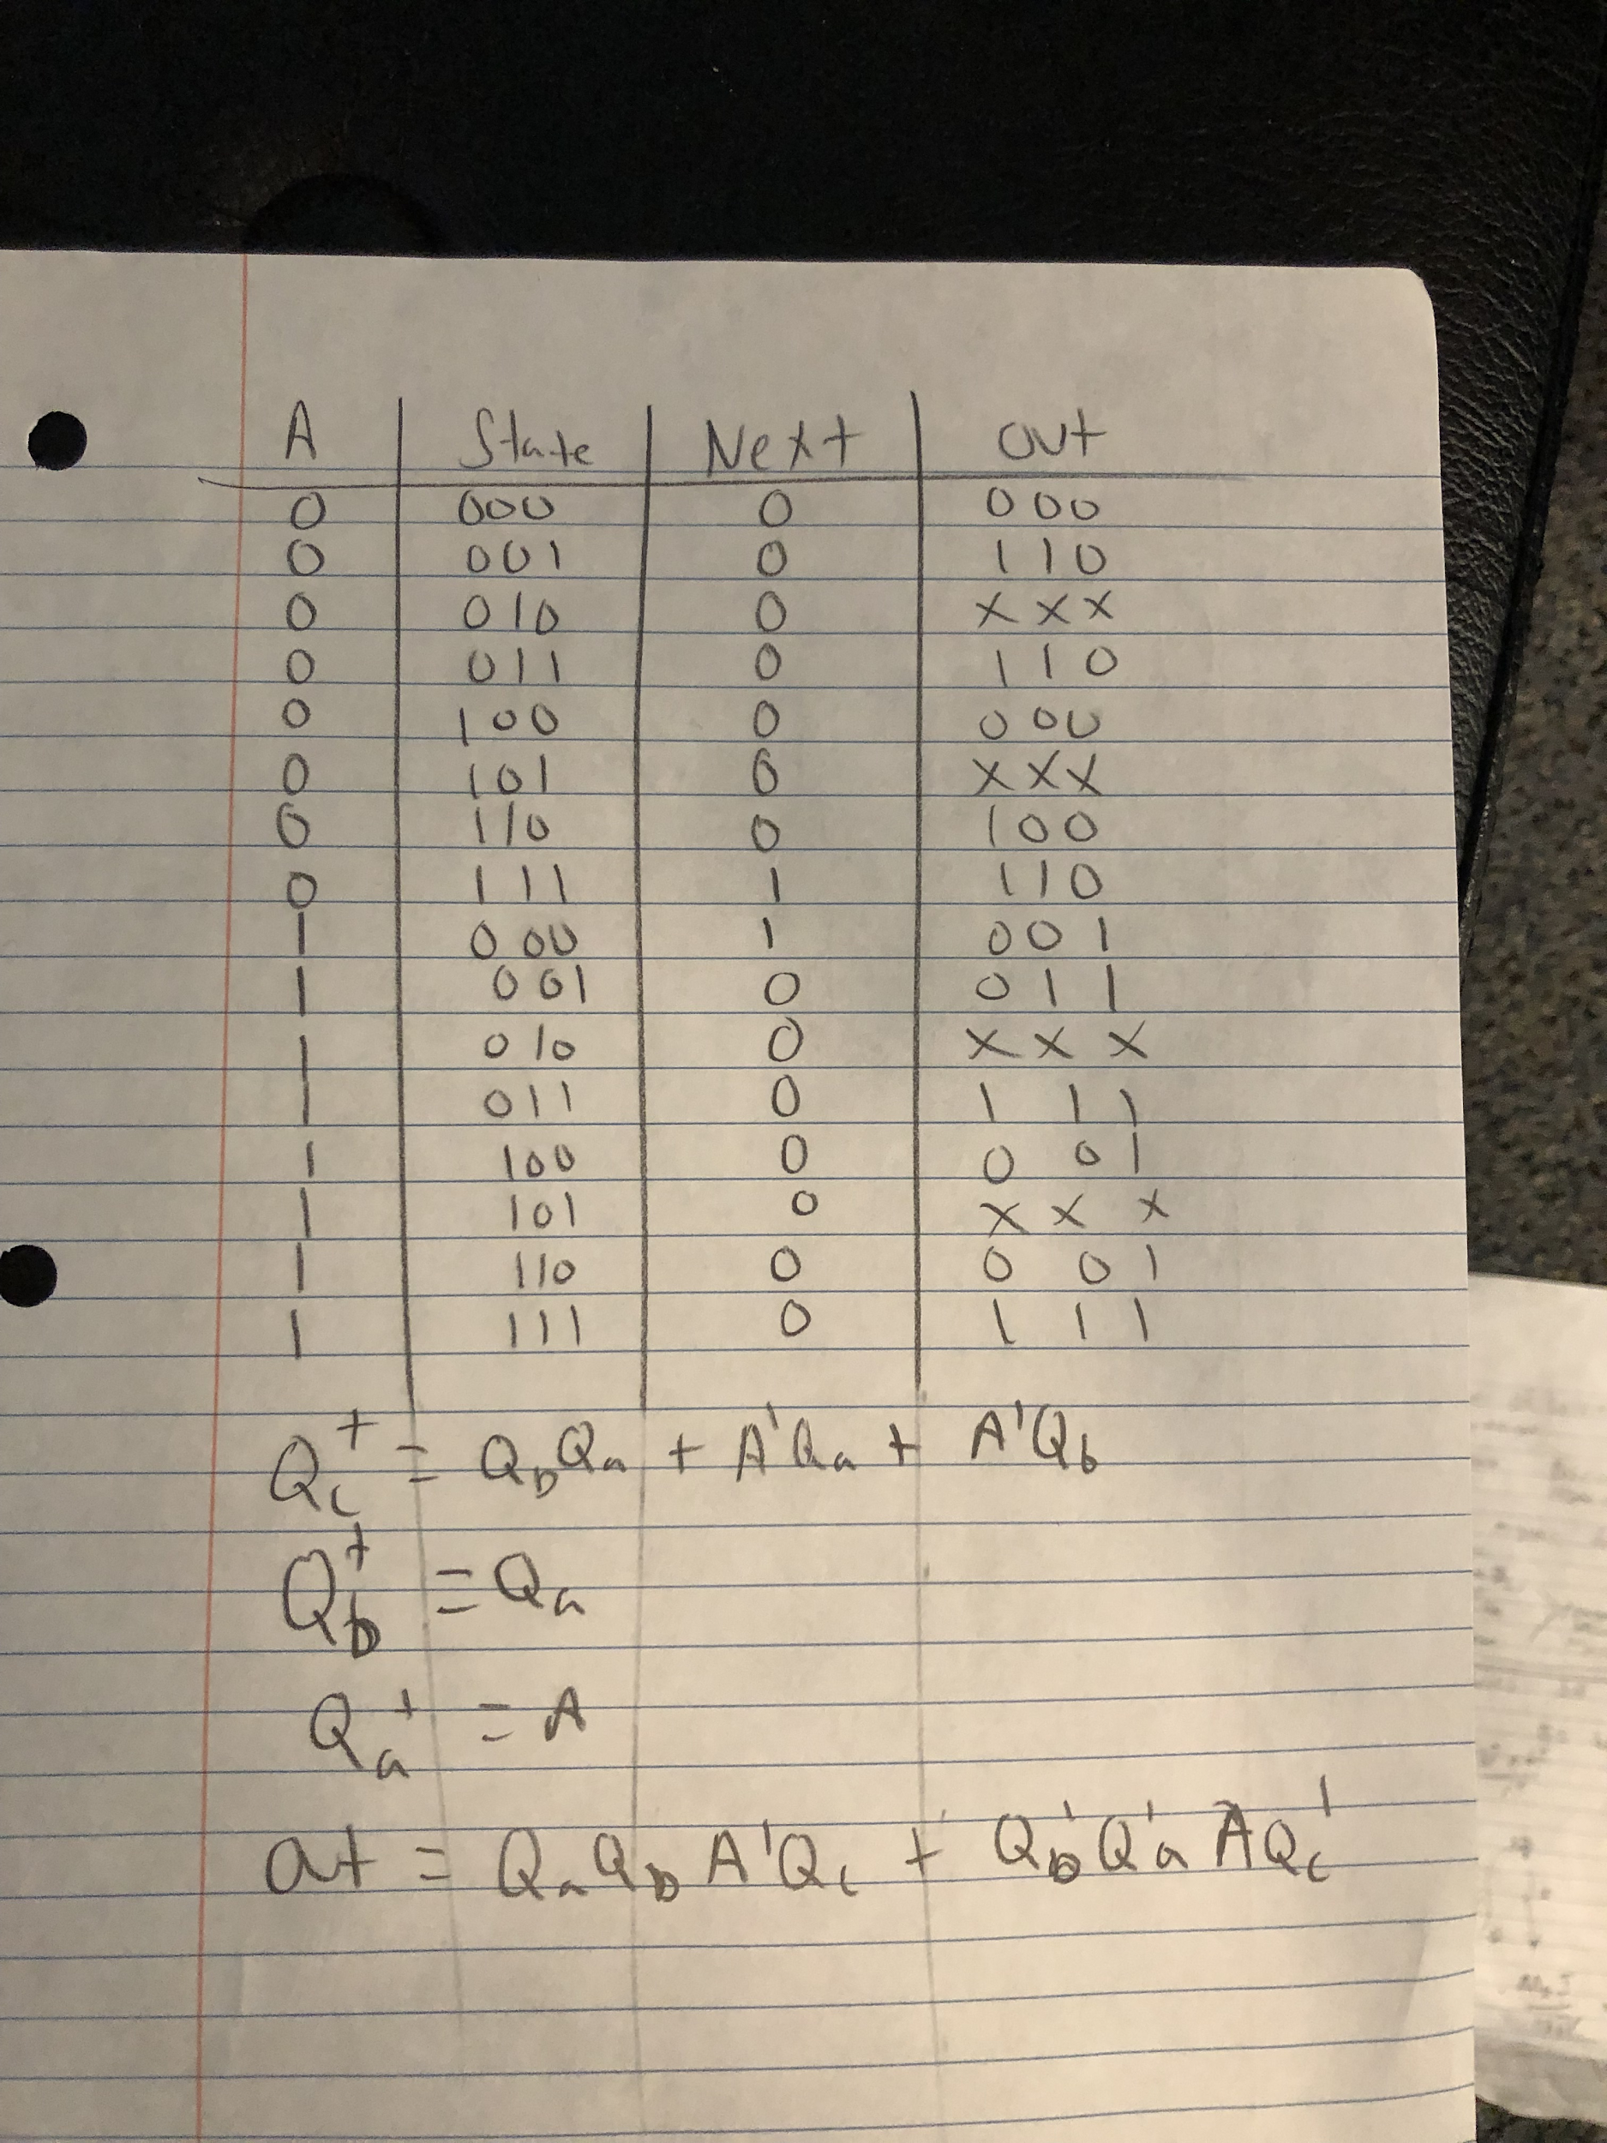

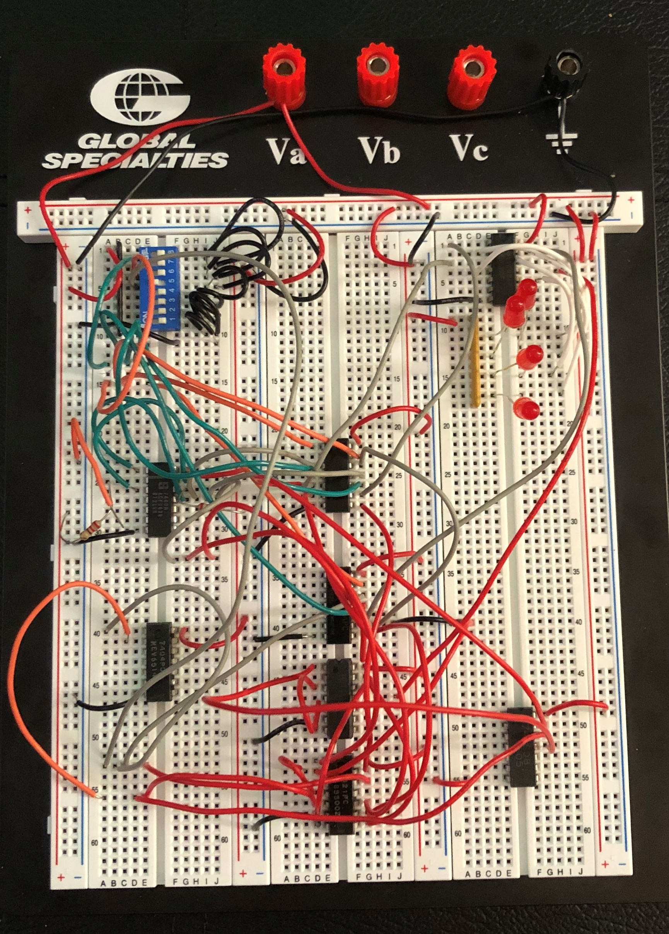

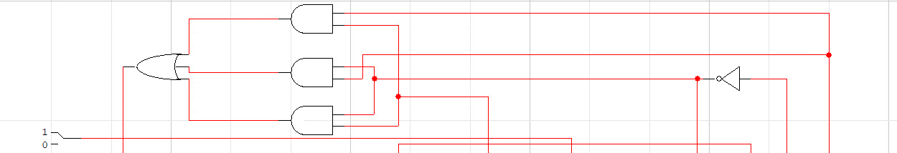

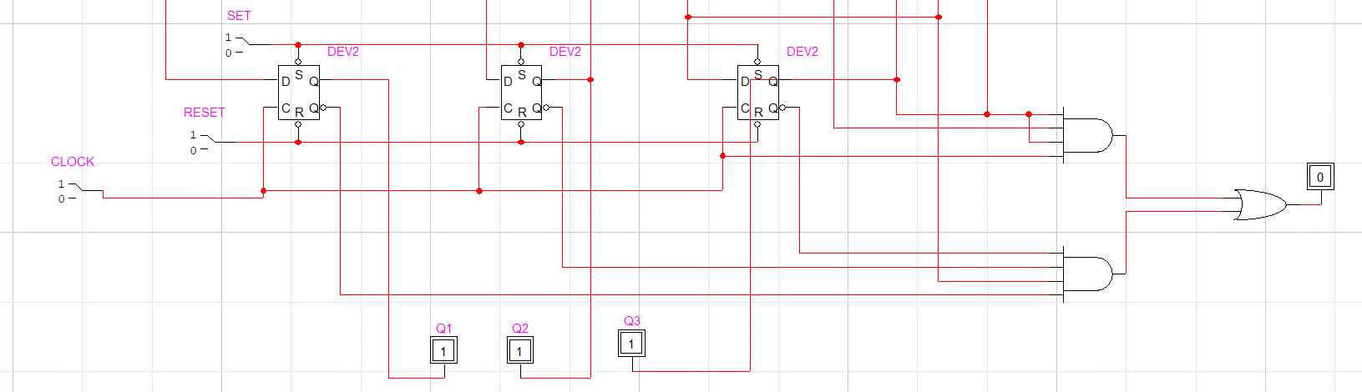

(I apologize I could not get the full circuit in the screenshot)

**Discussion:**

The results from this lab that I came out with were that my logicworks circuit worked but my physical hardware circuit did not fully work. This can be attributed to just any number of errors when building the circuit or issues with possibly the proto board or interference from close connections of wires. I believe though that as it states in the discussion section of the lab report pdf that “ a negative results is often as valuable as a positive result” I should receive full credit for this lab. All my logic was correct it and the error could not even be something fixable on the physical circuit.

**Conclusions:** In conclusion what I took away from this lab is that sometimes no matter what you do the physical circuit might not work. That being said I think students should not be punished for this. This lab was a good lab it was not as bad as the fourth lab but I would say its second. This was a great class this year I plead you guys curve the final grades and have a good break.